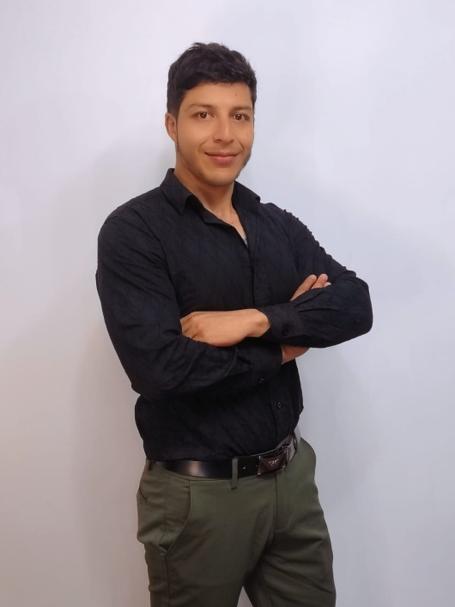




Av.Jorge Perez Concha
Linkedin
- PMP®

- Project & Transformation Leader

- Tech & Data-Driven Execution

(+593) 99 6162 657

kevinviteri42@gmail.com

PROFESSIONAL SUMMARY

Passionate and results-driven Project Manager with 6+ years of experience leading digital transformation initiatives across the education, service, and industrial sectors. Strong background in agile project delivery, partner success, and cross-functional team leadership. Currently pursuing a Master’s in Data Science, with growing expertise in data-driven strategy and process optimization. Proven ability to manage stakeholder relationships, build long-term value, and translate technical solutions into impactful business outcomes. PMP Certificate
EXPERIENCIA LABORAL
Product Owner (Freelance) - Conta RS - 2021 – Present
- Led automation initiatives for accounting services, reducing delivery time by 30%.
- Managed partner expectations and implemented digital product solutions with direct impact on business performance.
- Coordinated multidisciplinary teams applying OKRs and agile methodology.

Lecturer - Coordinator of Degree - PUCE - 2025 - Present
- Guided students in real-world innovation projects tied to industry needs.
- Taught project management methodologies and agile frameworks.
- Collaborated with multiple internal stakeholders for research, innovation, and curriculum improvement.
Lecturer in project management, software development projects, leadership, digital tools, programming fundamentals, and thesis supervision.

Consultant - Lecturer - Ecuadorian-German Chamber of Commerce – January 2024 – January 2025 Freelance)
- Technical consulting and training in process analysis and improvement tools (TPM, Ishikawa, Pareto, 5 Whys).
- Co-design of academic and operational structures for dual training programs, including regulatory and operational requirements.
- Budget consulting for the design of academic curricula and technical laboratories.
Maintenance Supervisor - Maquipharma - 2021 - 2024
- Managed SAP-based workflows for industrial maintenance operations.
- Led TPM implementation under ISO 9001 standards.
- Coordinated engineering, quality, and logistics to ensure high uptime and compliance.
Desarrollador Junior - TOTEM - 2019 - 2021
- Developed features for banking and financial systems.
- Supported agile development cycles with QA and customer feedback tracking.
- Participated in DevOps and backend automation initiatives.

HABILIDADES BLANDAS
- Comunicación efectiva con equipos y stakeholders
- Pensamiento estratégico orientado a resultados
- Negociación y resolución de conflictos
- Adaptabilidad y resiliencia en entornos cambiantes.
- Liderazgo de equipos multidisciplinarios

TECHNICAL SKILLS

- Project Management (Scrum, Kanban, OKRs)
- Stakeholder Engagement and Partner Development
- Python, SQL (basic), Power BI, Excel
- JIRA, MS Project, Notion, Confluence
- Process Optimization and Data VisualizationFluent Spanish, Intermediate Business English
EDUCATION

- Master’s in Data Science – Universidad San Francisco de Quito (In progress, 2025)
- MBA – Instituto Europeo de Posgrados (2024)
- MSc. in Project Management – Universidad Europea de Monterrey (2024)
- Bachelor in Mechatronics Engineering – Universidad de las Fuerzas Armadas ESPE (2023)
CURSOS Y CERTIFICACIONES
- Certificación PMP | PMI
- Mentoría Universitaria I PUCE I Septiembre – Octubre 2025
- Experto en Gestión Agile de Proyectos (SCRUM-KANBAN) I CCE I Julio - Agosto 2025
- Diplomando de Docencia Universitaria I PUCE I Abril - Julio 2025
- Applied Data Science with Python Level II IBM I Junio 2025
- Data Fundamentals and Project Management Fundamentals II IBM I Abril 2025
- Artificial Inteligence Fundamentals with Capstone Project I IBM I Marzo - Abril 2025
- Entrenamiento Especializado en Propiedad Intelectual I CEDIA I Febrero - Abril 2025
- Liderazgo Organizacional I Universidad Santander I Septiembre - Octubre 2024
- The Basics of SCRUM I Project Management Institute (PMI) I Agosto 2024
- Finanzas para no Financieros I Universidad de Las Américas I Junio - Agosto 2024
- Metodologías Ágiles con OKR's I Universidad Santander I Noviembre - Diciembre 2023
- Evaluación Financiera de Proyectos I Politécnico de Colombia I Agosto - Septiembre 2022
REFERENCIAS LABORALES
- Coordinadora de Desarrollo de Software PUCE: Diana Molina +593-987-721-889
- Gerente de Operaciones Conta RS : Rocío Saltos +593-996-036-210
- Coordinador Empresarial AHK: Ricardo Cevallos +593-987-062-105
- Jefe de Mantenimiento Maquipharma: William Baque +593-999-061-348
- Jefe de Desarrollo TOTEM: Patricio Espinosa +593-987-041-140
REFERENCIAS PERSONALES

- Presidente del PMI Andes Pacífico: Javier Muñoz +593 99563663
- Dr. Paul Proaño: +593-984-931-621
- Commercial and Customer Sucess Leader ICOMM: Lenin Cueva +593-998-116-991

